Ch 3.1-3.4 Guided Notes

Represent Distributions of Quantitative Variables with Histograms

[1.1] Record times for you and your partner to the nearest second
Yours: | Partner's:

[3.1; 3.2] Draw histograms to represent the distribution of the 20 data points below
4, 5, 10, 11, 12, 15, 17, 18, 19, 19, 20, 20, 21, 25, 30, 30, 36, 39, 47, 50

binwidth = 2 | binwidth = 10
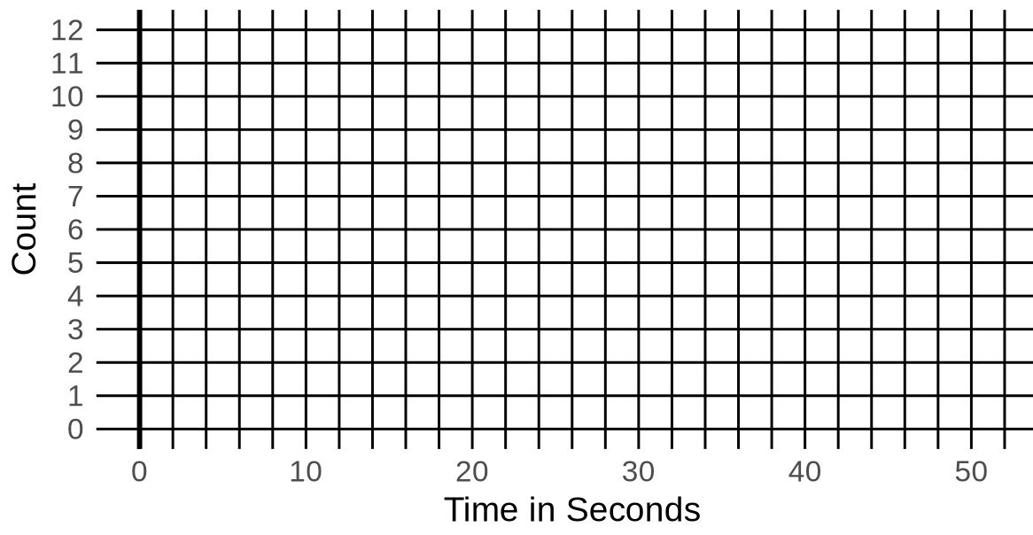 | 

[4.2, 4.3] Write the R code to create the two histograms above
binwidth = 2:

binwidth = 10:

[5.2] Write the R code to make a histogram of time_standing_on_left_leg in the census dataset

[5.7] What's a bin? What's a binwidth?

What is the relationship between the number of bins and binwidth?

[6.1] Describe the shape, center, spread, and weird things in the distribution of time_standing_on_left_leg from census

